AN ASSESSMENT ON

LOAN ELIGIBILITY DATA ANALYSIS

INDIVIDUAL REPORT BY: EFFIOM, EMMANUEL
EDEM

TRACK NO.: 22/132021

DATASET: LOAN ELIGIBILITY DATASET

GROUP 3

SUBMITTED TO DR. MRS. SYLVIA OLADIMEJI

IN PARTIAL FULFILMENT OF THE REQUIREMENT TO THE DEPARTMENT OF
MATHEMATICS & COMPUTER SCIENCE

FACULTY OF NATURAL AND APPLIED SCIENCE ARTHUR JARVIS UNIVERSITY,
AKPABUYO, CROSS RIVER STATE.

JANUARY 2026.

1. Overview of the Project Domain
Loan eligibility assessment is an important application of data science in the financial sector. Financial institutions rely on applicant information such as credit history, employment status, loan amount, and property location to determine whether a loan should be approved or rejected.
This project analyzes a housing loan dataset to understand how different applicant attributes relate to loan approval status.

2. Introduction to the Dataset
- Dataset Files Used:
- train_ctrUa4K.csv
- test_lAUu6dG.csv
- Data Source: Loaded locally using the pandas library
- Key Features Observed in the Dataset:
- Gender
- Married
- Dependents
- Self_Employed
- Credit_History
- LoanAmount
- Loan_Amount_Term
- Property_Area
- Loan_Status
- Target Variable Analyzed:
- Loan_Status

3. Description of the Problem or Questions Explored
The analysis focuses on understanding patterns related to loan approval by exploring the following questions:
- How is loan approval (Loan_Status) distributed across different property areas?
- What is the relationship between credit history and loan approval status?
- How does loan approval vary with loan amount terms?

4. Data Cleaning Steps
The dataset was cleaned and prepared using Python and the pandas library as shown in the notebook:
- Data Loading:
The training and test datasets were loaded using pd.read_csv().
- Missing Value Identification:
Missing values were identified by computing the percentage of null values for each column.
- Handling Missing Values:
Missing data was handled using appropriate default replacements:
- Credit_History filled with 0
- Self_Employed filled with "No"
- LoanAmount filled with 0
- Dependents filled with "Other"
- Loan_Amount_Term filled with 0
- Gender filled with "Other"
- Post-cleaning Verification:
Missing value percentages were recalculated to confirm successful handling.

5. Dashboard Explanation and Insights
The notebook uses Seaborn and Matplotlib to visualize relationships between loan approval and selected features.

Title: Loan Status by Property Area
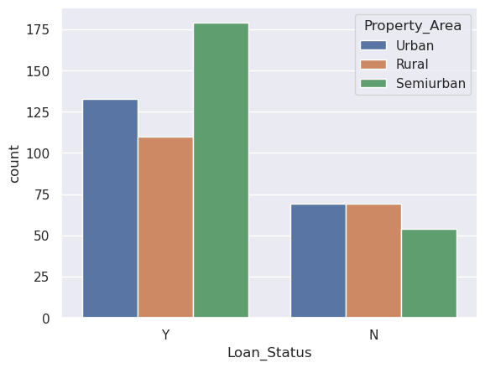
- Description:
A count plot showing loan approval and rejection across different property areas.
- Insight:
The visualization helps compare how property location relates to loan approval outcomes.

Title: Loan Status by Credit History
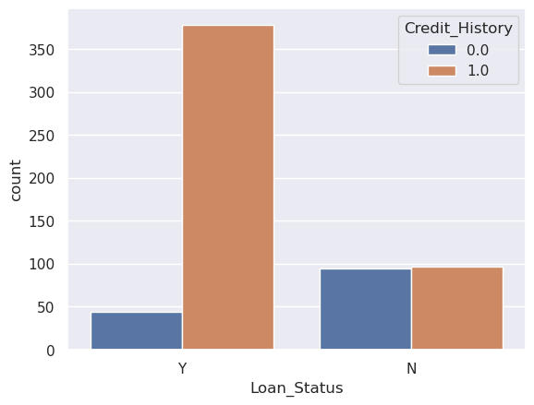
- Description:
A count plot illustrating loan status distribution based on applicants’ credit history.
- Insight:
Credit history appears to play a significant role in loan approval decisions.

Title: Loan Status by Loan Amount Term
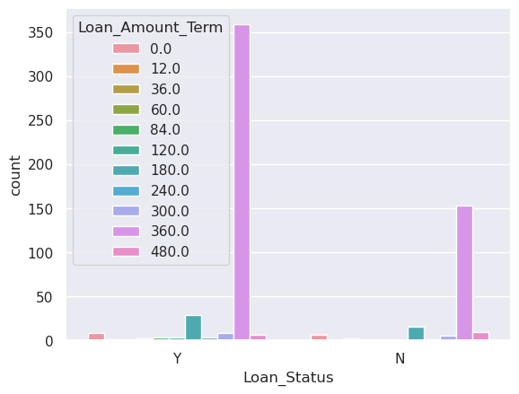
- Description:
A count plot showing how loan approval varies with different loan amount terms.
- Insight:
This visualization highlights how repayment duration may influence approval outcomes.

6. Conclusion
This analysis examined a housing loan dataset to understand factors influencing loan approval decisions. After loading the data, missing values were identified and handled appropriately to ensure data consistency. Visual analysis revealed clear relationships between loan status and features such as credit history, property area, and loan amount term.
The project provides a foundational understanding of loan eligibility patterns and sets the stage for future predictive modeling.

REFERENCES
- Dataset Files:
- train_ctrUa4K.csv
- test_lAUu6dG.csv
- Analysis Tool:
- Jupyter Notebook (Untitled0.ipynb)
- Libraries Used:
  - Pandas
  - NumPy
  - Matplotlib
  - Seaborn

